Macbeth: Discussion Questions
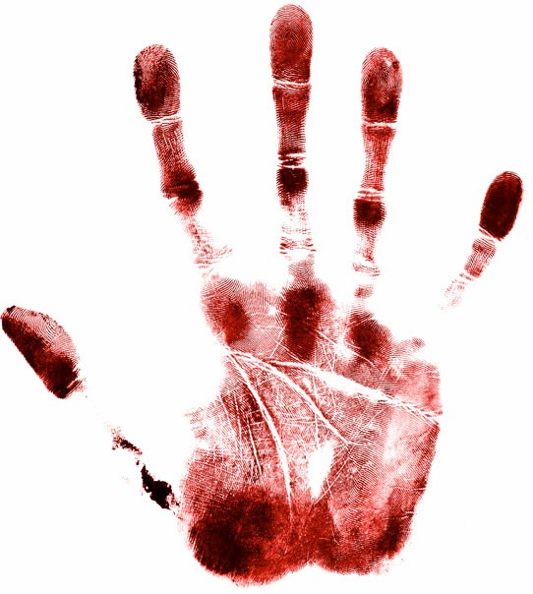

- For Aristotle, Macbeth would not "count" as a tragedy, since Macbeth appears too evil to be a proper tragic hero. But he does not begin the play as an evil character. Note statements concerning Macbeth's past, i.e. his role and reputation prior to the beginning of the play. What has he accomplished, and how is he rewarded? What is King Duncan's opinion of him? Is it justified? How fundamentally does Macbeth change in the course of the play? Pinpoint key moments in his evolution from war hero to tyrant.

- One of the Aristotelian principles of tragedy is that the hero's downfall is caused by a moral weakness or flaw that inexorably leads him to his tragic destiny. In this respect, can Macbeth be seen as an Aristotelian tragedy? What basic human flaws or weaknesses does Macbeth display? How do they contribute to his downfall?

- The three witches have been seen as figures of the Greek Moirae (Latin Parcae), or Fates, who respectively spin, measure out and cut the thread of human life. Note how the scenes with the "weird sisters" (Old Eng. wyrd=Fate) punctuate and structure the play. To what extent do their predictions dictate events? Are their prophecies binding? Is Macbeth trapped by destiny, a victim of fate, or does he have free will? How do we know? Note specific scenes and speeches that justify your point of view.

- Banquo is a foil to Macbeth in that both are the subject of prophecies concerning the future kingship of Scotland, but they react to these prophecies differently. How does each respond to his encounter with the witches? Are there key differences? Why does Shakespeare include two sets of prophecies? What is the effect of this juxtaposition?

- Macbeth begins with three witches chanting "fair is foul and foul is fair" (I.i.10), a line which evokes a world upside down, the reversal of the natural order. Look for other indications of nature gone awry within the play. Where does natural imagery occur? Note references e.g. to weather, vegetation, animals and birds, sterility and fertility, disease and health. What is the connection between this imagery and events in the play? For Shakespeare, "natural" behavior includes love for one's family and the loyalty between subject and liege lord; mistreating kinsmen or betraying one's rightful leader is "unnatural.” Note examples of such "natural" and "unnatural" behavior (and occurrences of these words and of "nature") in Macbeth. Since treachery and betrayal play significant roles in the plot, look also for the familiar Shakespearean themes of the difficulty of distinguishing between appearance and reality (allusions to disguises, masks, clothing, etc.) and the power of language to deceive (flattery, lies, double meanings, ambiguity).

- Macbeth displays high regard for his wife, Lady Macbeth, who is a surprisingly equal partner in their marriage (a situation that many in Shakespeare's time would find "unnatural"). Pick out references to their partnership or feelings for each other throughout the play. What is the effect of these details? (To excuse Macbeth from responsibility for his actions? To humanize him by showing him in at least one "natural" relationship? Or what?) Overall, do Macbeth and Lady Macbeth appear to have a good marriage? Are they well matched? Do they feel real affection for each other?
To what extent is Lady Macbeth responsible for Duncan's murder? Are she and Macbeth equal partners in crime? Does their relationship (and their collaboration) shift over time? At what point does Macbeth start to act alone, without her help or knowledge? Read carefully Lady Macbeth's words in the sleep-walking scene. What do you think caused her breakdown? What prior events does she allude to, and what does she have to say about them? How does Macbeth react to the news of his wife's death? How does her death change him as a character?

- Apart from the Weird Sisters, there are only two significant female characters in the play. Compare/contrast Lady Macbeth and Lady Macduff. Are they foils to one another? Why or why not? What do they have in common? How do they differ? Lady Macduff is defined principally as a mother, while Lady Macbeth is apparently childless (see IV.iii.216). Nonetheless, Lady Macbeth says that she has "given suck, and [knows]/ How tender 'tis to love the babe that milks [her]" (I.vii.54-55). Can that shared experience of motherhood be seen as a bond between the two women? Does Lady Macbeth share the blame for Lady Macduff's murder? Does she approve of her husband's actions? Before she dies, Lady Macduff complains of her husband's "unnatural" behavior in abandoning wife and children (IV.ii.9). Is her anger justified?

- At the end of the play, Macduff kills Macbeth in a scene easily read as the victory of Good over Evil. But would that be an accurate characterization? Is Macbeth wholly evil? (Consider e.g. his initial heroism in the war against Norway; his love for his wife; any other factors that may serve to make him seem more "human" or believable.) By the same token, is Macduff wholly good? (Is he really blameless? What mistakes has he made? Of what is he guilty?) Are we dealing here with entirely "black" and "white" characters, like the "good guys" and the "bad guys" in an old western, or is there some "gray" area? And if so, is that a strength or a weakness of the play? What is the effect of this moral ambiguity?

- In some respects, Macbeth is a meditation upon "manhood." It explores "natural" and "unnatural" gender behavior, offering varying views on what constitutes real "manhood." Note statements throughout the play that deal with "manliness," masculine identity, being a man, etc. How do the various characters in the play define "manhood"? How do these definitions shift over the course of the play?

