ELIT 46B, Major British Writers (Neoclassical to Romantic 1660-1830)

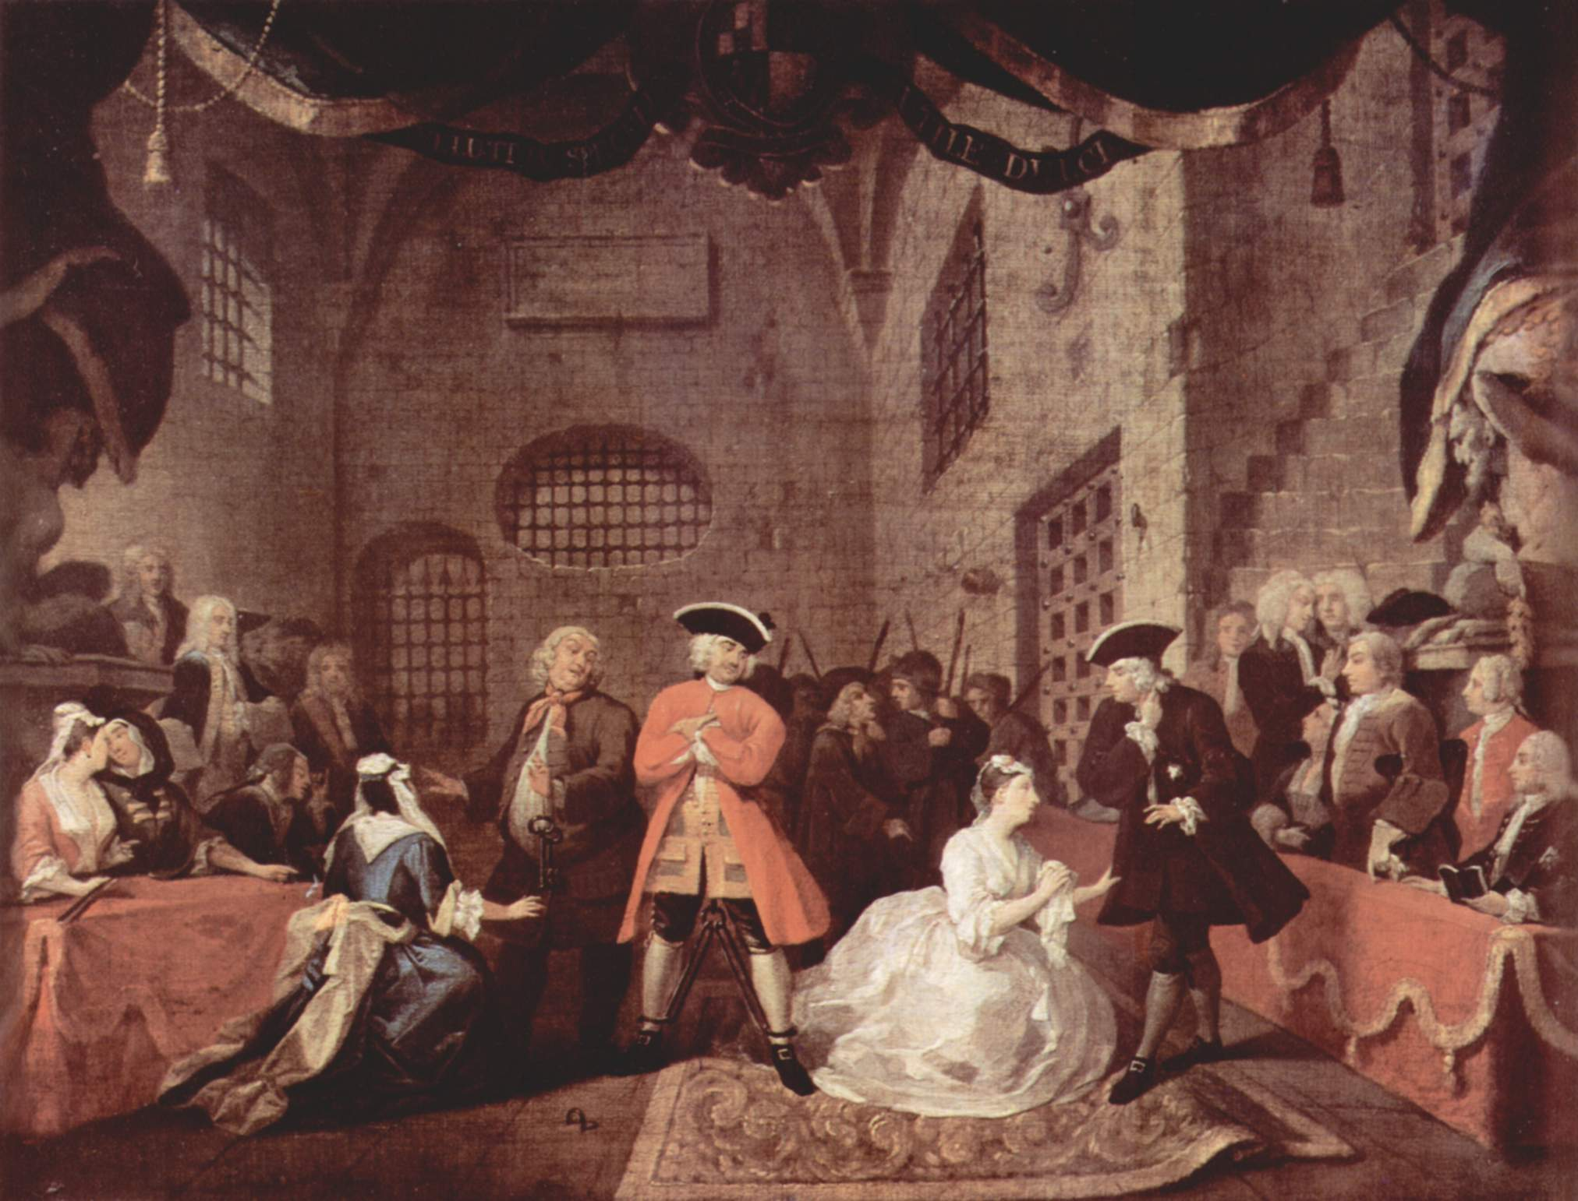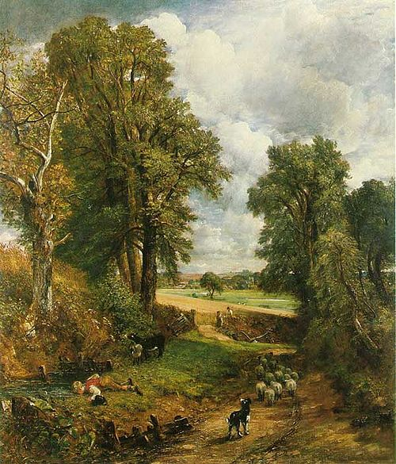

Instructor: Julie Pesano
Phone/ E-mail: (408) 864-8653 E-mail: pesanojulie@fhda.edu or jpesano@gmail.com
Website: http://deanza.edu/faculty/pesanojulie/elit-46b.html
Class Time/ Location: Monday/Wednesday 10:30-12:20 MQ-2A
Office Location: F61L (In L Quad near Turtle Sculpture)
Office Hours: Monday and Wednesday, 12:30-1:30
Or By Appointment (Please let me know when you plan to stop by – thanks!)

Course Advisory: Eligibility for EWRT 1B or ESL 6.

Required Texts: 1. Greenblatt, et. al. The Norton Anthology of English Literature: 8th Ed.Volumes C and D
(Those who plan to enroll in Elit 46C may wish to purchase Vol. 2 in its entirety).
2. Mary Shelley Frankenstein: Or the Modern Prometheus
(Please get the 1831 edition not the 1818, and if you can, try to get the Penguin Classics ISBN 978-0140433623 at bookstore or online.
http://www.amazon.com/Frankenstein-Modern-Prometheus-Penguin-Classics/dp/0140433627
Course Description
Welcome to the pendulum swing of the head and the heart! This course covers British literature from the Neoclassical Era: 1660 to 1785 (some say 1789), a time which reflects the logical, left brained, scientific perspective to the Romantic Era: 1785-1830, a time which reflects the emotional, right brained, imaginative perspective. It is good to remember that the dates are general and somewhat arbitrary. Certain Romantic traits can be seen as early as the Renaissance era which precedes the Neoclassical, and Neoclassical traits may be found well into the Romantic era. Regardless, notice which era you are drawn to as you might discover your own dominant head or heart perspective. Isn’t literature really just mirror of ourselves, anyway!
Student Learning Outcomes
- Acquire knowledge of the historical and cultural period, major writers, and key texts of Neo-Classical and Romantic British Literature.
- Develop critical thinking skills by applying a variety of critical and theoretical criteria to the evaluation of Neo-Classical and Romantic British Literature.

Grading: You are required to complete all assignments. Assignments and readings are due at the beginning of the class period on the due date. Late assignments will be penalized; the later the paper, the greater the penalty. Absence or technology problems are no excuse. A final grade for the course will be assigned on the basis of performance in the following areas:

Analytical Literary Responses: 20% (2 responses = 10% each)
Presentation: 20%
Quizzes: 10% (unannounced, no make-ups)
Participation: 10%
Midterm 20%, Final Exam: 20%

Scale: 97-100%=A+, 93-96%=A, 90-92%=A-, 87-89%=B+, 83-86%=B, 80-82%=B-, 77-79%=C+, 70-76%=C, 67-69%=D+, 63-66%=D, 60-62%=D-, 59% and below=F

*** Extra credit: (Optional) – Get creative! Write a poem, essay, brief short story in the style of one of our authors. For example, write a satirical poem in the style of the Rochester slamming someone or something you want to mock (celebrity, your parents, the De Anza registration process!) Maximum 1-2 pages, typed, double space, on 8.5x11 white paper. This is worth 1% of your total grade (or the equivalent to 5 points in your quiz section). You may do a maximum of 1 and turn it in any time before the end of the quarter.

Attendance: Students must attend the first week of class to secure their enrollment.
Participation: Participation means
- Being in your seat, ready to work at the beginning of class;
- Being actively engaged in what is going on in the classroom;
- Taking responsibility for your learning process in this class;
- Asking for help when you do not understand something;
- Working willingly and appropriately with your classmates in pairs and groups;
- Listening respectfully when others are talking;
- Doing the homework before you come to class;
- Not checking or answering your cell phone in class or leaving class to take a call.

Honesty: (Plagiarism) I am interested in your ideas as well as how clearly you can discuss the ideas of others. If you use the ideas of anyone else (printed, friends, on-line), acknowledge your source immediately in parentheses (MLA style). If you use the words of a source, use quotation marks and acknowledge the source. Plagiarism automatically results in a zero for the assignment with no opportunity for makeup. If you are uncertain about the rules for using a source, come see me before you turn in the assignment.

About Course Content:
This is an adult level course; therefore, the subject matter of readings and discussions will contain adult material and will not be censored.

The Reading Load:
This class is a literature class, so the reading load is high! Do the best you can, and if you fall behind, it is your job to catch up, not the course’s job to slow down. Also, the texts we read can and will be challenging, so please make sure to take good notes and come up with questions as you read so that you can be prepared to participate in class.

Need Money?
De Anza’s Financial Aid Office, on the bottom floor of the Hinson Center (near Campus Police) gives out many scholarships!The website is http:www.deanza.fhda.edu/financialaid/scholist.htm or contact Cindy Castillo (408)864-8403 or castillocindy@fhda.edu.
Need Special Accommodations?
If you have any special circumstances that you feel may influence your performance in this class (a diagnosed learning disability, physical disability, or anything at all that might interfere with your learning), please come chat with me so that we can create a learning environment that works for you.

Welcome to the class! Please let me know if you have any questions. I encourage you to throw your heart into the learning, and the grade will follow. I look forward to working with and learning from all of you. JP

Important Dates: (see http://www.deanza.edu/calendar/)
Saturday, Jan. 19 :: Last day to add quarter-length classes. Add date is enforced.

Sunday, Jan. 20 :: Last day to drop for a full refund or credit (quarter-length classes). Drop date is enforced.

Sunday, Jan. 20 :: Last day to drop a class with no record of grade. Drop date is enforced.

Friday, March. 1 :: Last day to drop with a "W." Withdraw date is enforced.

ELIT 46B Tentative Schedule Winter 2019
- All readings below come from The Norton Anthology or Frankenstein
- Complete Readings before the week meeting and be reading for unannounced quizzes.

Week 1 The Restoration

1/7-1/9 Introduction to the course
Reading Assignment: “The Restoration and the Eighteenth Century 1660-1785” 2057-2082
John Wilmot, Second Earl of Rochester 2167 “Satyr on Charles II” http://andromeda.rutgers.edu/~jlynch/Texts/charles2.html
Sample Quiz on Reading
Assign Presentations

Week 2 Satire
1/14- 1/16 {Presentation #1 – 1/14}
Reading Assignment: John Dryden 2083-2084 “MacFlecknoe” 2111-2117
“Wit as ‘Propriety’” 2131, “The Art of Satire” 2131-2132

Week 3 Political Allegory
1/21 - 1/23 Martin Luther King Jr. Holiday – No Class 1/21
{Presentation #2 1/23}
Reading Assignment: Jonathan Swift 2301-2303 “A Modest Proposal” 2462-2468, Gulliver’s Travels Part 1 (2323-2365)

Week 4 Height of Neoclassicism
1/28 - 1/30 {Presentation #3 – 1/28}
Reading Assignment: Alexander Pope 2493-2496, “The Rape of the Lock” 2514-2532

Week 5 Rise of the Novel
2/4 - 2/6 {Presentation #4 – 2/6}
Reading Assignment: Aphra Behn 2178-2180 Oroonoko, or The Royal Slave 2183-2226 Analytical Response #1 due 2/6

Week 6
2/11 - 2/13 Review for Midterm 2/11 Midterm Exam 2/13

Week 7 Early Romanticism
2/18 -2/20 President’s Holiday – No Class 2/18
{Presentation #5- 2/20}
Reading Assignment: Switch to Volume D of the Norton Anthology “The Romantic Period 1785-1830” 1-22
William Blake 76-79 Songs of Innocence and Experience 81-97

Week 8 Romantic Movement Continued (The Lake Poets)
2/25 - 2/27 {Presentation #6 – 2/25}
Reading Assignment: William Wordsworth 243-245, Lyrical Ballads 245-274 Samuel Taylor Coleridge 424-426 “The Rime of the Ancient Mariner” 430-446

Week 9 Later Romanticism
3/4 - 3/6 {Presentation #7 – 3/4}
Reading Assignment: George Gordon, Lord Byron 607-611, “She walks in beauty” 612, “When we two parted” 613, Don Juan Canto 1 669-697
Percy Bysshe Shelley 741-744 “Mont Blanc” 762-766

Week 10 The Gothic Novel
3/11 - 3/13 {Presentation #8 – 3/11}
Reading Assignment: “The Gothic and the Development of Mass Readership” 577-579
Frankenstein by Mary Shelley
Letters - Volume 2 Chapter 2 (Chapt 10) (p. 13-98 in Penguin Edition)

Week 11
3/18- 3/20 Reading Assignment: Frankenstein by Mary Shelley
Volume 2 Chapter 3 (chapt. 11) – end (pages 99-215 in Penguin Edition)
Analytical Response #2 due 3/20

Week 12
3/27 Final Exam Wednesday 3/27 9:15-11:15

